NOTICE OF ADVERSE ACTION

Date

Applicant Name
Address
City State Zip Code

Re: Notice of Adverse Action – Your Application for Employment

Dear Applicant:

We regret to inform you, based on our hiring criteria, we are unable to consider you further for an employment opportunity with our organization. This decision was based in whole or in part upon information we received from the Consumer Reporting Agency listed below:

LS Screening, LLC.
PO Box 270152
Austin, TX 78727
(800) 755-3392

In accordance with the Fair Credit Reporting Act, please find enclosed a “Summary of Your Rights Under The Fair Credit Reporting Act”. You also have the right to obtain an additional free copy of the report and/or to dispute the accuracy of this report within 60 days of your receipt of this letter by contacting LS Screening. All requests must be in writing and may only be requested by the individual who is the subject of the consumer report.

Please note: LS Screening did not make the decision to take this adverse action and will not be able to provide you with specific reasons why this decision was made.

Thank you for your interest in employment with our organization. We wish you the best in your employment search.

Regards,

Hiring Manager

67748 Federal Register/Vol. 77, No. 220/Wednesday, November 14, 2012/Rules and Regulations

Para informacion español, visite www.consumerfinance.gov/learnmore o escribe a la Consumer Financial Protection Board, 1700 G Street N.W., Washington DC 20552.

A Summary of Your Rights Under the Fair Credit Reporting Act

The federal Fair Credit Reporting Act (FCRA) promotes the accuracy, fairness, and privacy of information in the files of consumer reporting agencies. There are many types of consumer reporting agencies, including credit bureaus and specialty agencies (such as agencies that sell information about check writing histories, medical records, and rental history records). Here is a summary of your major rights under the FCRA. For more information, including information about additional rights, go to www.consumerfinance.gov/learnmore or write to: Consumer Financial Protection Board, 1700 G Street N.W., Washington DC 20552

- You must be told if information in your file has been used against you. Anyone who uses a credit report or another type of consumer report to deny your application for credit, insurance, or employment – or to take another adverse action against you – must tell you, and must give you the name, address, and phone number of the agency that provided the information.

- You have the right to know what is in your file. You may request and obtain all the information about you in the files of a consumer reporting agency (your “file disclosure”). You will be required to provide proper identification, which may include your Social Security number. In many cases, the disclosure will be free. You are entitled to a free file disclosure if:
- a person has taken adverse action against you because of information in your credit report;
- you are the victim of identify theft and place a fraud alert in your file;
- your file contains inaccurate information as a result of fraud;
- you are on public assistance;
- you are unemployed but expect to apply for employment within 60 days.

In addition, all consumers are entitled to one free disclosure every 12 months upon request from each nationwide credit bureau and from nationwide specialty consumer reporting agencies. See www.consumerfinance.gov/learnmore for additional information.

- You have the right to ask for a credit score. Credit scores are numerical summaries of your credit-worthiness based on information from credit bureaus. You may request a credit score from consumer reporting agencies that create scores or distribute scores used in residential real property loans, but you will have to pay for it. In some mortgage transactions, you will receive credit score information for free from the mortgage lender.

- You have the right to dispute incomplete or inaccurate information. If you identify information in your file that is incomplete or inaccurate, and report it to the consumer reporting agency, the agency must investigate unless your dispute is frivolous. See www.consumerfinance.gov/learnmore for an explanation of dispute procedures.

- Consumer reporting agencies must correct or delete inaccurate, incomplete, or unverifiable information. Inaccurate, incomplete, or unverifiable information must be removed or corrected, usually within 30 days. However, a consumer reporting agency may continue to report information it has verified as accurate.

- Consumer reporting agencies may not report outdated negative information. In most cases, a consumer reporting agency may not report negative information that is more than seven years old, or bankruptcies that are more than 10 years old.

- Access to your file is limited. A consumer reporting agency may provide information about you only to people with a valid need – usually to consider an application with a creditor, insurer, employer, landlord, or other business. The FCRA specifies those with a special need for access.

- You must give your consent for reports to be provided to employers. A consumer reporting agency may not give out information about you to your employer, or a potential employer, without your written consent given to the employer. Written consent generally is not required in the trucking industry. For more information, visit www.consumerfinance.gov/learnmore.

- You may limit “prescreened” offers of credit and insurance you get based on information in your credit report. Unsolicited “prescreened” offers for credit and insurance must include a toll free number you can call if you choose to remove your name and address from the lists these offers are based on. You may opt out with the nationwide credit bureaus at 1-800-XXX-XXXX.

- You may seek damages from violators. If a consumer reporting agency, or, in some cases, a user of consumer reports or a furnisher of information to a consumer reporting agency violates the FCRA, you may be able to sue in state of federal court.

- Identity theft victims and active duty military personnel have additional rights. For more information, visit www.consumerfinance.gov/learnmore.

States may enforce the FCRA, and many states have their own consumer reporting laws. In some cases, you may have more rights under state law. For more information, contact your state or local consumer protection agency or your state Attorney General. For information about your federal rights, contact:

67750 Federal Register / Vol. 77, No. 220 / Wednesday, November 14, 2012 / Rules and Regulations

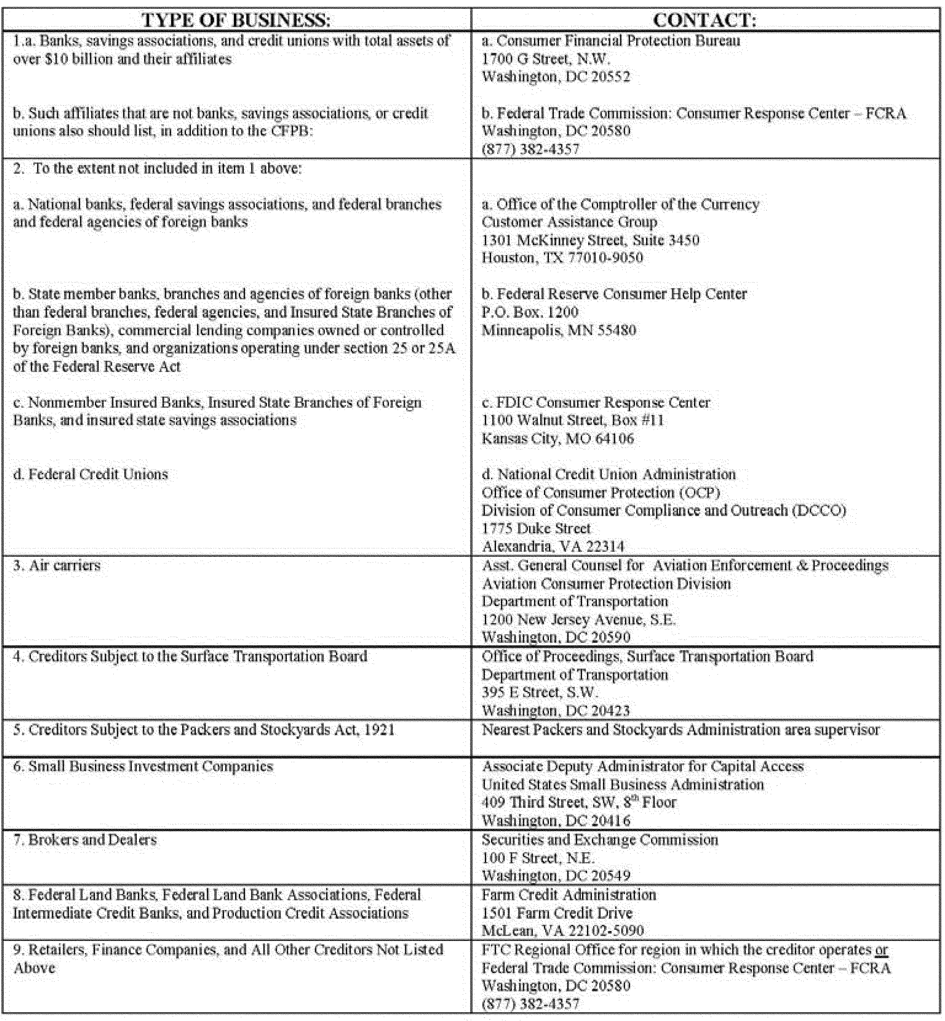

■ 4. Revise Appendix M to read as follows:
Appendix M to Part 1022—Notice of
Furnisher Responsibilities
The prescribed form for this disclosure is a separate document that is substantially similar to the Bureau’s model notice with all information clearly and prominently displayed. Consumer reporting agencies may limit the disclosure to only those items that they know are relevant to the furnisher that will receive the notice.

